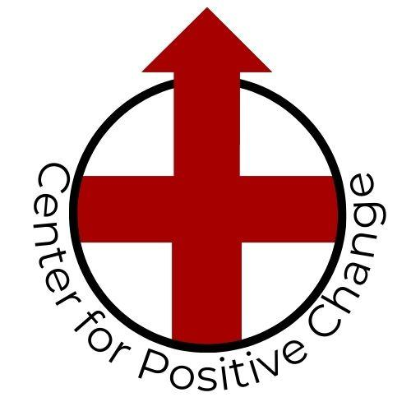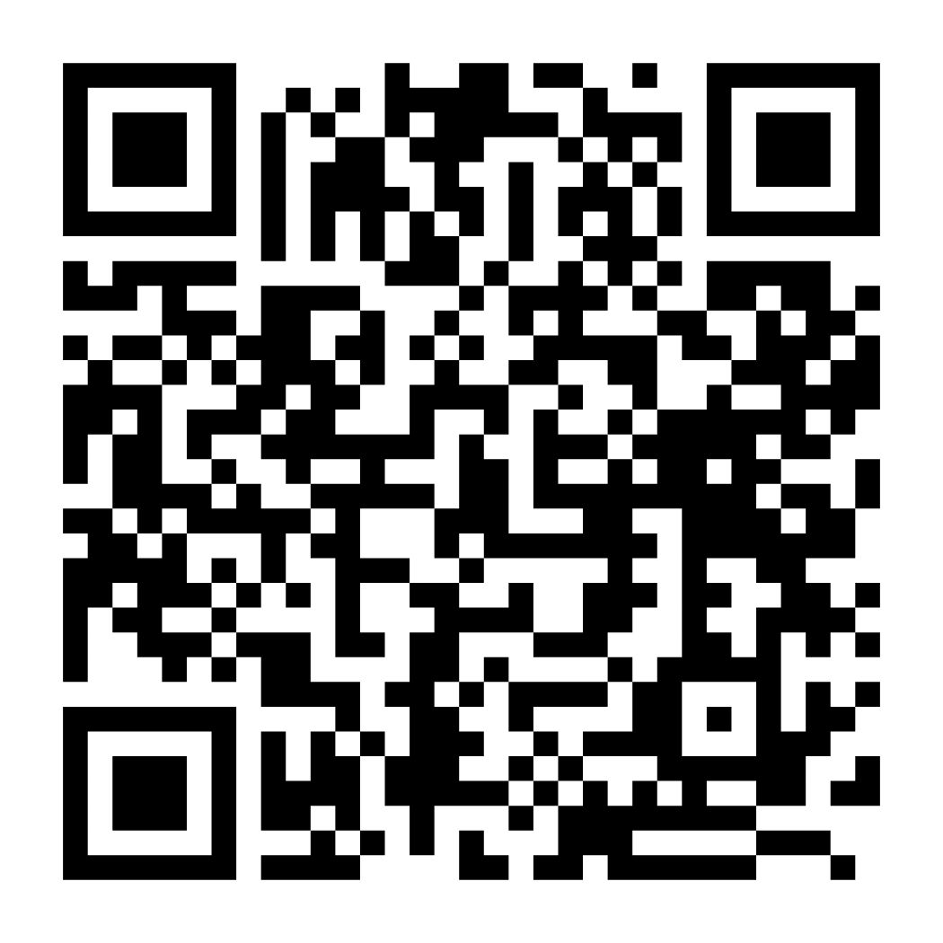

Community Resources

## Mental Health: Crisis Counseling/Therapy/Life Skills

* **Oaklawn Open Access Clinic**

**Contact:** Toll-Free 1-800-282-0809

→ *South Bend* (Open Access Clinic,24/7) → *Elkhart County* (Open Access Clinic, 24/7)  
 Address : [415 E. Madison St.](https://www.google.com/maps/dir/415+E+Madison+St,+South+Bend,+IN+46617/@41.6805277,-86.2474602,17z/data=!4m8!4m7!1m0!1m5!1m1!1s0x8816cd47ec0dc2c3:0x18fa4807b94ebe83!2m2!1d-86.2452715!2d41.6805277)  Address : [2600 Oakland Ave.](https://www.google.com/maps/dir/2600+Oakland+Ave,+Elkhart,+IN+46517/@41.6608042,-85.9856394,17z/data=!4m8!4m7!1m0!1m5!1m1!1s0x8816c30fd7e4a0ad:0xd74fe8cbe355d285!2m2!1d-85.9834507!2d41.6608042)

574-283-1234 574-533-1234

→ *Mishawaka Campus*  
 574-259-5666

* Monday – 8 a.m.-2 p.m.
* Tuesday – 8 a.m.-2 p.m.
* Wednesday – 12-6 p.m.
* Thursday – 10 a.m.-4 p.m.
* Friday – 8 a.m.-2 p.m.

[**https://oaklawn.org/our-services/**](https://oaklawn.org/our-services/)

* **Oaklawn Crisis Center**: M-F : 8am-5pm 420 N. Niles Ave. South Bend

Crisis Center Brochure: [Crisis Centers (oaklawn.org)](https://oaklawn.org/wp-content/uploads/2024/03/Crisis-Centers-1.pdf)

* **Memorial Epworth Center**

(Psychiatric hospital for adults and adolescents ages 13 and above. Provide short-term stabilization and support to people who are experiencing a psychiatric emergency that cannot be managed in an outpatient setting)

**Contact:**

420 N. Niles Ave., South Bend, IN 46617

Ph: (574) 647-8400 available 24hr/day, 365 days/year

[**https://locations.beaconhealthsystem.org/in/south-bend/memorial-epworth-center**](https://locations.beaconhealthsystem.org/in/south-bend/memorial-epworth-center)

* **Bowen Center St Joseph County**

**Contact:**

1-800-342-5653

[**https://www.bowencenter.org/**](https://www.bowencenter.org/)

* **National Alliance on Mental Illness**

**Contact:**

Text “NAMI” to 741741 free 24/7 confidential crisis counseling/ mental health support

[**https://namisjc.org/**](https://namisjc.org/)

## Mental Health: Crisis Counseling/Therapy/Life Skills (continued)

* **Suicide Prevention Lifeline**

**Contact:**

1-800-273-TALK (8255) free 24/7 confidential hotline

* **Mental Health Awareness of Michiana**

(free short term counseling for families and individuals who do not have insurance or unable to afford mental health counseling - children under the age of 18 can be counseled with the family, but not individually)

*up to 12 sessions offered over 3-6 months*

**Contact:**

Linda Raven (ProBono Counseling coordinator)

Ph:(547) 343-0918 / email: [lraven@mhamichiana.org](mailto:lraven@mhamichiana.org)

Link to online application for counseling:

[**https://forms.mhamichiana.org/?nocache=true**](https://forms.mhamichiana.org/?nocache=true)

* **Warmlines**

(A warmline is a **non-crisis** peer to peer support line. Warmlines can talk about recovery, empowerment, mental health challenges, or just day-to-day life! Any age can call to chat. *they are NOT counselors*

Warmline operates 8am - 4:30pm Monday - Friday.)

*This is a FREE service offered through Key Consumer Org.

**Contact:**

1-800-933-5397

## Family/Parenting Development

* **Real Services**

Family Development Program:

* Referrals for assistance
* Career and job-seeking guidance
* Vocation training
* Finance and budgeting lessons
* Complete basic education
* Housing and home ownership guidance
* Childcare resources
* Nutrition information
* Home care and management training
* Parenting skills sessions
* Time management skills courses
* Confidence training

**Contact:**

574-284-2060

[**https://realservices.org/services/community-action/**](https://realservices.org/services/community-action/)

## Family/Parenting Development (continued)

* **Families First**

(parent education/ group classes/ supervised visitation facility)

**Contact:**

605 Portage Ave Monday: 9am–8pm

South Bend, IN 46616 Tuesday: 9am–8pm

(574) 287-4375 Wednesday: 9am–8pm

Thursday: 9am–8pm

Friday: 9am–8pm

Saturday: 9am–4pm

Email: [admin@familiesfirstcenter.org](mailto:admin@familiesfirstcenter.org)

[**https://familiesfirstcenter.org/**](https://familiesfirstcenter.org/)

* **SCAN/Community Partners**

(Short-term family assistance, connection to community resources to strengthen families & fulfill needs)

**Contact:**

Phone: 1-800-752-7116

[**https://www.scanfw.org/community-partners**](https://www.scanfw.org/community-partners)

## Food Assistance

* **Food Bank of Northern Indiana**

**Contact:**

702 Chapin Street  
South Bend, Indiana 46601  
Phone: (574) 232-9986

***Find a pantry near you:*** [**https://feedindiana.org/food-pantries**](https://feedindiana.org/food-pantries)

* **Family & Social Services Administration: SNAP & TANF Benefits**

Supplemental Nutrition Assistance Program (SNAP) and Temporary Assistance to Needy Families (TANF)

**Contact:**

Find your office: [**https://www.in.gov/fssa/dfr/ebt-hoosier-works-card/find-my-local-dfr-office/**](https://www.in.gov/fssa/dfr/ebt-hoosier-works-card/find-my-local-dfr-office/)

[**South Bend Office, St. Joseph County Division of Family Resources**](https://www.in.gov/fssa/dfr/ebt-hoosier-works-card/find-my-local-dfr-office/st-joseph-county/st-joseph-south-bend-dfr-office)   
 401 E. Colfax Ave., Suite 375  
 South Bend, IN 46617-2737  
 Telephone/fax number: **1-800-403-0864**  
 **ZIP codes:** 46536, 46552, 46554, 46574, 46595, 46601, 46613, 46614, 46615, 46616, 46617, 46619, 46624,

46626, 46628, 46634

[**Mishawaka Office, St. Joseph County Division of Family Resources**](https://www.in.gov/fssa/dfr/ebt-hoosier-works-card/find-my-local-dfr-office/st-joseph-county/st-joseph-mishawaka-office)   
 102 N. Center St., Suite 500  
 Mishawaka, IN 46544-1232  
 Telephone/fax number: **1-800-403-0864**  
 **ZIP codes:** 46530, 46544, 46545, 46546, 46556, 46561, 46635, 46637, 46660, 46680, 46699

## Food Assistance (continued)

* **Feed a Friend, South Bend**

Free Community Fridge offering fresh food & drinks with miscellaneous donations of dry goods/household items

**Location:**

1310 Portage Ave: Near Northwest Neighborhood Building (fridge located inside a shed on the California Ave side of the building)

[**https://www.feedafriendsouthbend.com/**](https://www.feedafriendsouthbend.com/)

## Community Centers

* **One Roof / United Way of St. Joseph County**

(Community Navigators on site to assist with social, health, youth and senior services - *El Campito Child Development Center is located at the Dubail Ave. site)

**Contact:**

Monday-Friday: 8am-5pm

405 E Dubail Ave, South Bend, IN

(574) 393-8809

[**https://uwsjc.org/community-impact/southeast-neighborhood-center/**](https://uwsjc.org/community-impact/southeast-neighborhood-center/)

* **La Casa de Amistad Youth & Community Center**

(Bilingual Social Service Coordinators assist with health, mental health, education, jobs, citizenship, legal matters, housing, utilities, food access & crisis management. Youth & Adult Programs are offered at a low cost)

**Contact:**

3423 S Michigan St, South Bend, IN

(574) 233-2120

[**https://www.lacasadeamistad.org/**](https://www.lacasadeamistad.org/)

* **Charles Black Community Center**

(After School programs, recreation center, computer lab, music studio, hot meals) *$10 month

**Contact:**

3419 W Washington St., South Bend, IN 46619

Office: 574-235-9446

[**https://sbvpa.org/places/lasalle-park/charles-black-recreation-center/**](https://sbvpa.org/places/lasalle-park/charles-black-recreation-center/)

* **Unity Gardens**

(Offers free gardening classes and seasonal produce from their community gardens, monthly “Hotcakes & Haircuts” event offering free haircuts with pancakes or hotdogs, offers a free men's support group: “Contemplate”-meet every other Thursday, check their social media Facebook page for up-to-date events or call/visit the Unity Gardens Welcome Center for newly added events)

**Contact:**

3701 Prast Blvd.

South Bend, IN. 46628

(574) 222-2266

Sara Stewart, Executive Director

sara@theunitygardens.org

​574-315-4361

[**https://www.theunitygardens.org/**](https://www.theunitygardens.org/)

## After School Programs

* **Boys & Girls Clubs of St. Joseph County**

(*\*currently a waitlist*\* Free after school program/ Before Care available at select schools at rate of $35 per week)

**Contact:**

Phone: (574) 232-2048 Email: [info@bgcsjc.org](mailto:info@bgcsjc.org)

[**https://www.bgcsjc.org/enrollment**](https://www.bgcsjc.org/enrollment)

* **Charles Black Community Center**

(After School programs, recreation center, computer lab, music studio, hot meals) *$5 month

**Contact:**

3419 W Washington St., South Bend, IN 46619

Office Ph: (574) 235-9446

[**https://sbvpa.org/places/lasalle-park/charles-black-recreation-center/**](https://sbvpa.org/places/lasalle-park/charles-black-recreation-center/)

* **La Casa de Amistad Youth & Community Center**

(Afterschool Tutoring and Enrichment Program Grades K-5: Academic Year, Monday-Thursday, 3-5PM, $40 per Month Scholarships Available)

**Contact:**

3423 S Michigan St, South Bend, IN

(574) 233-2120

[**https://www.lacasadeamistad.org/elementary.html**](https://www.lacasadeamistad.org/elementary.html)

* **Heroes Camp**

(\**For MALE Youth only*\* Free Recreational Programs, hot meal served during programs)

Hours: Wednesday & Friday: 3pm-6pm; Saturday: 10am-1pm

*Open tours every Saturday at 10am

**Contact:**

4130 Hickory Road, Mishawaka, IN 46545

Office Ph: (574) 243-1055

[**https://heroescamp.com/contact-4**](https://heroescamp.com/contact-4)

* **Big Brothers Big Sisters Program**

(*\*currently a waitlist*\* Free enrollment for the program. A ‘Big” is paired with child providing mentorship during or after school)

**Contact:**

Big Brothers Big Sisters Southern Lake Michigan Region

Program Support Specialist: Denise Rose

Email: denise@becomeabig.com

Call/text: 574-240-7554

Online Youth Enrollment (for parent/guardian to complete): [**https://bbbs.tfaforms.net/4967294**](https://bbbs.tfaforms.net/4967294)

*If a parent/guardian is unable to complete the online application, a referral agency may complete a referral using the Online enrollment form for referral agencies: [**https://bbbs.tfaforms.net/f/ReferAChild**](https://bbbs.tfaforms.net/f/ReferAChild)

## Hospitality Centers for the Homeless

* **City of South Bend Resources for Homelessness**

(Food, Shelter, Clothing, Laundry Services, Showers, Phone & Mail programs for the homeless)

**Click** the **link below** to find a center/services & weather amnesty guidelines for 2023/2024

[**https://southbendin.gov/department/community-investment/homelessness/**](https://southbendin.gov/department/community-investment/homelessness/)

* **Broadway Christian Parish**

(*They Do Not Provide Housing!* They provide hospitality programs: Breakfast, Showers, Toiletries, Laundry Facilities, Clothing Pantry & Family Resources)

Monday-Thursday 8:00am-10:00am

**Contact:**

1412 Carroll St., South Bend, IN 46613

Phone: (574) 289-0333

[**https://www.broadwaychristianparish.org/**](https://www.broadwaychristianparish.org/)

* **Center for the Homeless**

(Residential facility for homeless individuals & families)

**Contact:**

813 S.Michigan St., South Bend, IN 46601

Phone: (574) 282-8700

[**https://www.cfh.net/**](https://www.cfh.net/)

* **Hope Ministries**

(Emergency & transitional housing when available, meals served daily, case managers assist with connecting families to community resources & Hope4 kids Program supports child based needs while residing at the facility)

**Contact:**

432 S. Lafayette Blvd., South Bend, IN 46601

Phone: (574) 235-4150

[**https://hopesb.org/about-us#programs**](https://hopesb.org/about-us#programs)

## Healthcare

* **Family & Social Services Administration: *Medicaid\***

**Contact:**

[**South Bend Office, St. Joseph County Division of Family Resources**](https://www.in.gov/fssa/dfr/ebt-hoosier-works-card/find-my-local-dfr-office/st-joseph-county/st-joseph-south-bend-dfr-office)   
401 E. Colfax Ave., Suite 375  
South Bend, IN 46617-2737  
Telephone/fax number: **1-800-403-0864**  
**ZIP codes:** 46536, 46552, 46554, 46574, 46595, 46601, 46613, 46614, 46615, 46616, 46617, 46619, 46624, 46626, 46628, 46634

[**Mishawaka Office, St. Joseph County Division of Family Resources**](https://www.in.gov/fssa/dfr/ebt-hoosier-works-card/find-my-local-dfr-office/st-joseph-county/st-joseph-mishawaka-office)   
102 N. Center St., Suite 500  
Mishawaka, IN 46544-1232  
Telephone/fax number: **1-800-403-0864**  
**ZIP codes:** 46530, 46544, 46545, 46546, 46556, 46561, 46635, 46637, 46660, 46680, 46699

[**https://fssabenefits.in.gov/bp/#/**](https://fssabenefits.in.gov/bp/#/)

## Healthcare (continued)

* **HRSA Health Center Program**

(Health Resources & Services Administration- Low-Cost/Sliding fee Scale Medical, Dental, Vision Health Centers)

**Contact:**

Health Center Program Support 1-877-464-4772, 8:00 a.m. to 8:00 p.m. ET, Monday-Friday (except federal holidays)

[**https://findahealthcenter.hrsa.gov/**](https://findahealthcenter.hrsa.gov/)

* **Vaccines For Children Program**

(Offers Federally funded vaccines for eligible children to 18 yrs. of age)

**Contact:** *utilize the interactive map linked below to find local health centers that provide the service

[**https://www.in.gov/health/immunization/vaccines-for-children/vfc-provider-map/**](https://www.in.gov/health/immunization/vaccines-for-children/vfc-provider-map/)

## Clothing Assistance / Household Goods

* **The Fig Leaf Boutique**

(offers 10 free items of clothing per person {newborn-adult sizes} every three months)

**Contact:**

Location: 125 E. Mishawaka Ave., Mishawaka, IN46545

Hours: 10:30 am-1:00 pm each Thursday & 2nd and 4th Thursdays of each month from 6-8pm.

[**FigLeafBtq@gmail.com**](mailto:FigLeafBtq@gmail.com)

* **Christ Child Society**

(Clothing for Infants through 14 years of age)

*Requires a referral from a local social services agency {limited distribution dates/times}

Location:  2366 Miracle Lane, Mishawaka, Indiana 46545

**Contact:**

(574) 288-6028

[**https://www.christchildsb.org/need-help/**](https://www.christchildsb.org/need-help/)

* **St.Vincent DePaul** *\*Clothing & Household Goods Vouchers* to use at select Goodwill Stores*

Approved vouchers are only distributed in person at St. Vincent DePaul Center: 520 Crescent Ave. South Bend, IN, Tuesdays & Thursdays 10am until 2pm.

*You must complete a voucher application online first! - click on the link below and scroll down to the ‘Apply Now’ button*

**Contact:**

(574) 234-6000

Click on the link below for Eligibility Requirements & Goodwill Store locations for voucher redemption:

[**https://www.svdpsb.org/clothing-vouchers**](https://www.svdpsb.org/clothing-vouchers)

* **Caring Clothing Co-op**

(offers free used clothing & household goods, availability varies weekly depending on donations received)

Open: Tuesdays 4pm-7pm *Eastern* Time & Thursdays 4pm-7pm *Eastern* Time, *except holidays

Location: 6019 N. 750 E. New Carlisle, IN

**Contact:**

(574) 654-8829 (Crystal Lewis)

## Clothing Assistance / Household Goods (continued)

* **The Community Reserve**

(offers free used furniture, household goods, some appliances-availability depends on donations received)

*Requires a referral from a Case Manager* A Case Manager must speak directly with either Judy or Marv to schedule an appointment for the family to pick up items. Warehouse located in New Carlisle.

**Contact:**

The CASIE Center (574) 282-1414, *ask to speak with a Truancy Prevention Program Case Manager to arrange a referral for needed items

* **Kingdom Closet *Business Temporary location: 1519 Portage Ave. South bend**

(Thrift store offering clothing for $1 per item, unless marked otherwise.)

Hours: Tuesday-Friday 12pm-5pm, Saturday 11am-4pm

Location: **(building fire 1/29/2024 at original location)**

**Contact:**

(574) 440-1198

* **Broadway Christian Parish**

(Hospitality programs: Breakfast, Showers, Toiletries, **Laundry Facilities**, **Clothing Pantry** & Family Resources)

Monday-Thursday 8:00am-10:00am

1412 Carroll St., South Bend, IN 46613

Phone: (574) 289-0333

[**https://www.broadwaychristianparish.org/**](https://www.broadwaychristianparish.org/)

* **Busy Hands of Michiana**

(provide handmade therapeutic items for individuals/families with life challenging situations: cancer, autism, dementia, etc. - Products: weighted vests, fidget/sensory toys, squiggle pillows, chew necklaces, wheelchair/walker bags, etc.)

*\*Requires a referral from an Agency* - click on the link below to contact a listed Agency

[**https://busyhandsofmichiana.org/agencies/**](https://busyhandsofmichiana.org/agencies/)

## Bedding

* **Hope to Dream**

(Free twin size bed for each child age 3yr. to 16yr. living in poverty, must be nominated by a school social worker, case manager, church leader, or charitable organization)

Click on the Link below to Nominate a child:

[**https://www.ahopetodream.com/en/nominate?country=USA&region=IN&city=Mishawaka**](https://www.ahopetodream.com/en/nominate?country=USA&region=IN&city=Mishawaka)

* **Sweet Dreams Ministry**

(Free mattress, bed frame, pillow, sheets and blankets to children age 3yr-17yr., distributed only twice a year)

*Requires an application through a Referral Agency: Click on the link below to find a Referral Agency and eligibility requirements.

[**https://www.svdpsb.org/sweet-dreams-ministry**](https://www.svdpsb.org/sweet-dreams-ministry)

* **Cribs for Kids**

(*Eligible* families receive a free portable cribette/pack-n-play)

*distributed by Memorial Children’s Hospital*

**Contact:**

Memorial Children’s Hospital Ph: (574) 647-1000

615 N. Michigan St., South Bend, IN 46601

## Home Safety

* **Free Smoke Alarm & Carbon Monoxide Monitor Program**

(Eligible City of South Bend *Homeowners* (tenants not eligible) receive 2 free smoke alarms and 1 free carbon monoxide monitor. The South Bend Fire Department will install the devices free of charge in your home)

**Contact:**

Click the Link Below to fill out the application:

[**Smoke Alarm & Carbon Monoxide Alarm Program Application (office.com)**](https://forms.office.com/Pages/ResponsePage.aspx?id=5fjdxfV5706GYYHhhsUku8CsOoQYkC9Arn5cRilXZqJUNDFEMTQ0RE02RkZNVFFPTTBTNE1LMVI4OSQlQCN0PWcu)

*or you may stop by the Central Fire station at 1222 S. Michigan in South Bend between the hours of 8:00 am and 4:00 pm Monday-Friday and pick up an application.

* **Gear Up For Safety: Lutheran Social Services of Indiana Program**

(*Eligible families can receive free home safety equipment ❴pack-n-plays, car seats, baby gates,etc.❵ for children 17 years and younger. May reapply every 5 years for items. - Families cannot be enrolled in Healthy Families and parent must have legal custody of children)

**Contact:**

Call: (260) 426-3347 *It may take 5-10 business days for a Case Manager to contact you.

* **Poison Control**: 1-800-222-1222 (poison control tells you what to do if you swallow, splash, or get stung by something that might be harmful)

## Adult Education/Career Assistance

* **Indiana Department of Workforce Development**

(High School Equivalency Exam / Career Readiness)

**Contact:**

1-866-220-6675

[**https://www.in.gov/dwd/career-training-adult-ed/adult-ed/**](https://www.in.gov/dwd/career-training-adult-ed/adult-ed/)

* **St. Joseph County Work One**

**Contact:**

(574) 237-9675

220 W. Colfax Ave (2nd Floor), South Bend, IN 46601

[**https://www.gotoworkone.com/home**](https://www.gotoworkone.com/home)

* **Goodwill Community Career Center**

**Contact:**

(574) 472-7300

1805 W. Western Ave., South Bend, IN 46619

[**https://www.goodwill-ni.org/**](https://www.goodwill-ni.org/)

* **South Bend Community School Corp. Adult Education**

(free: HSE diploma, Learn English Classes, Career Training)

[**https://southbendadulted.com/**](https://southbendadulted.com/)

## Financial Assistance / Housing Assistance

**TRUSTEES**: *THIS WILL BE YOUR FIRST STOP FOR FINANCIAL HELP*

Centre Township 574-291-7766 Clay Township 574-277-4452 German Township 574-272-9020 Greene Township 574-289-9942 Harris Township 574-272-2370 Liberty Township 574-656-4587 Lincoln Township 574-586-2812 Madison Township 574-850-0302 Olive Township 574-654-3231 Penn Township 574-256-6213 Portage Township 574-233-2126 Union Township 574-784-3110 Warren Township 574-288-8702

*Use This Link to Find Your Township: [**https://www.randymajors.org/what-township-am-i-in**](https://www.randymajors.org/what-township-am-i-in)

* **Housing Authority**

(HUD, Section 8, Housing Voucher, Family Self-Sufficiency Program)

* **South Bend Housing Authority** (serving South Bend City)

**Contact:**

(574) 235-9346

501 Alonzo Watson Dr., South Bend, IN 46601

[**https://hasbonline.com/get-in-touch/**](https://hasbonline.com/get-in-touch/)

* **St. Joseph County Housing Authority** (Serving St.Joseph County)

**Contact:**

(574) 256-9444

[2410 Grape Road, Mishawaka, IN 46545](https://www.google.com/maps/?q=2410+Grape+Road,+Mishawaka,+IN+46545/)

*waitlist for housing as of 10/2023

* **Indiana Emergency Rental Assistance (IERA) Program**

(provides financial assistance for rent and utility payments for Indiana residents)

**Contact:**

Toll-Free: 1-877-428-8844

[**https://indianahousingnow.org/press/articles/EmergencyRentalAssistance.html**](https://indianahousingnow.org/press/articles/EmergencyRentalAssistance.html)

**\***[**IERA Information Document for Renters**](https://www.in.gov/ihcda/files/ihcda_IERA2__RENTERS_0824.pdf)

* **United Religious Community Advocacy Center**

(assistance with housing & utility payments)

**Contact:**

(574) 282-2397 ext.2 / email: urcsjc@gmail.com

[**https://www.urcsjc.org/advocacy-center**](https://www.urcsjc.org/advocacy-center)

* **St Vincent De Paul**

(assistance with food, utilities, housing, clothing vouchers, home goods, Christmas Program)

*beds for children ages 3 – 17 through Sweet Dreams Ministry*

**Contact:**

(574) 234-6000

520 Crescent Ave., South Bend, IN 46617

[**https://www.svdpsb.org/financial-programs**](https://www.svdpsb.org/financial-programs)

* **Real Services**

(financial guidance/ housing assistance/ utility assistance/ weatherization)

**Contact:**

(574) 233-8205

[**https://realservices.org/household-assistance/**](https://realservices.org/household-assistance/)

## Financial Assistance / Housing Assistance (continued)

* **Habitat for Humanity of St. Joseph County**

(Homeownership program: *Click the Link Below* to check eligibility and requirements to apply)

[**https://www.hfhsjc.org/homeownership**](https://www.hfhsjc.org/homeownership)

**Contact:**

(574) 288-6967

* **St.Therese Little Flower Catholic Church**

(‘Whatsoever You Do Outreach Program’ - provides assistance to avoid utility disconnections/evictions)

**Contact:**

(574) 243-3437 *you must leave a detailed voice message, calls will be screened & returned based on current available funds AND complete the online ‘*Financial Assistance Application’* on the link below:

[**https://littleflowerchurch.org/outreach**](https://littleflowerchurch.org/outreach)

* **City of South Bend Utility Assistance Program (UAP)**

(Water and Sewer monthly bill reduction for City of South Bend residents)

**Contact:** *Click the Link Below* to check eligibility and apply

[**City of South Bend's Utility Assistance Program (UAP) Application (office.com)**](https://forms.office.com/pages/responsepage.aspx?id=5fjdxfV5706GYYHhhsUku4qfYS0IizNHq4mAKf56r_lUNjBYSDJNWllTNjcyVThBSTMzNkhSVTgySiQlQCN0PWcu)

* **Kroc Utility Assistance**

(Utility Assistance/ Financial Aid)

**Contact:**

(574) 367-2358 ext. 2206

*Call on Mondays, leave a detailed message about your bill, your name and your phone number. The Kroc Family Resource Center will return your call on Tuesday. If you do NOT receive a call back, call again the following Monday. All calls are logged, but assistance services are not guaranteed.

* **La Casa De Amistad**

(Team Heat Program-matches up to $50 per month towards heating bill November to March. \**Must complete a financial management program and attend monthly family development sessions to qualify)*

**Contact:**

(574) 233-2120 Monday-Thursday: 9am-12pm, 1pm-6pm Friday: 9am-12pm

[**https://www.lacasadeamistad.org/referrals.html**](https://www.lacasadeamistad.org/referrals.html)

## Legal Aid

* **Indiana Legal Services, Inc**

(Indiana residents with an income within 125% of Federal Poverty guidelines can receive free legal services)

**Contact:**

1-844-243-8570 ▪ call Monday-Thursday 10am-2pm

[**https://www.indianalegalservices.org/applyonline**](https://www.indianalegalservices.org/applyonline)

* **The Volunteer Lawyer Network, Inc**

(Residents with income below 200% poverty guidelines living in St. Joseph, Elkhart, LaPorte, Starke, Marshall, or Kosciusko counties can qualify for free legal services. *attorney placement requires a minimum of 30 days;

cannot accept emergency cases with hearings within 30 days)

**Contact:**

Ph:(574) 277-0075 ▪ email: [vlnsouthbend@probonoindiana.org](mailto:vlnsouthbend@probonoindiana.org)

*click the link below to check qualifications and services offered*:

[**https://www.volunteerlawyernetwork.net/what-we-do-1**](https://www.volunteerlawyernetwork.net/what-we-do-1)

* **Indiana Legal Help**

(Legal Self-representation resources for non-criminal issues)

*Click the link below to access forms and guides*

[**https://indianalegalhelp.org/info/**](https://indianalegalhelp.org/info/)

## Domestic Violence Support

* **Family Justice Center**

(Service agency for victims of domestic violence, stalking, and sexual assault)

**Contact:**

533 N. Niles Ave., South Bend, IN 46617

Ph:(574) 234-6900 Monday-Friday 8am-4:30pm

24-Hour Crisis Line: (574) 289-4357

[**https://www.fjcsjc.org/**](https://www.fjcsjc.org/)

* **YWCA North Central Indiana (South Bend)**

(Emergency shelter for victims of abuse)

**Contact:**

1102 Fellows St., South Bend, IN 46601

Ph:(574) 233-9491

[**https://www.ywcancin.org/who-we-are**](https://www.ywcancin.org/who-we-are)

* **National Domestic Violence Hotline: 1-800-799-7233**
* **National Sexual Assault Hotline: 1-800-656-4637**
* **National Human Trafficking Hotline: 1-888-373-7888**
* **Domestic Abuse Hotline for Men: 1-800-799-7233**

## Addiction Recovery

* **Alcohol & Addictions Resource Center**

(Alcohol and substance misuse education, prevention, intervention, assessment and referral services for individuals, families)

**Contact:**

818 E. Jefferson Blvd., South Bend, IN 46617

Ph: (574) 234-6024

[**https://aarcinfo.org/**](https://aarcinfo.org/)

* **Addiction Recovery Centers (ARC)**

(Provides outpatient services that are related to the misuse of one or more substances for adults 18 yrs. or older)

**Contact:**

2012 Ironwood Circle, Suite 200, South Bend, IN 46635 *additional locations in Elkhart, Goshen, LaGrange

Ph: (574) 807-8690 Monday-Friday 9am-5pm

[**https://arcenters.com/**](https://arcenters.com/)

* **The Upper Room Recovery Community**

(Provides safe and stable transitional housing to adults in recovery from addiction to drugs and alcohol)

**Contact:**

333 N. Main St., South Bend, IN 46601

For intake inquiries to the *Men’s Residence*, call 574-229-2032

For intake inquiries to the *Women’s Home*, call 574-400-3519

Email: info@upperroomrecovery.org

[**https://upperroomrecovery.org/**](https://upperroomrecovery.org/)

* **Substance Abuse & Mental Health Services Administration (SAMHSA)**

(Online resource to locate a treatment facility - A Division of the U.S. Department of Health & Human Services)

**Contact:**

*Link to locate a Treatment Center:*

[**https://findtreatment.gov/**](https://findtreatment.gov/)

*Over-the-Phone Location Assistance:*1-800-662-4357 (available 24/7, 365 days/yr)

## Disability Assistance & Support

* **Division of Disability & Rehabilitative Services (District 2)**

(Manages the delivery of services to children and adults with intellectual and developmental disabilities - Bureau of Developmental Disability Services, First Steps, Vocational Rehabilitation)

**Contact:**

401 E. Colfax Ave., Suite 270, South Bend, IN 46617

Ph: (574) 232-1412 Monday-Friday 8:00am-4:30pm

[**https://www.in.gov/fssa/ddrs/about-ddrs/**](https://www.in.gov/fssa/ddrs/about-ddrs/)

* **Autism Society of Indiana**

(Non-profit organization-does not provide direct assistance, such as treatment or legal services, however, they provide information and referrals to many services and supports across the State)

**Contact:**

Ph: 1-800-609-8449

[**https://www.autismsocietyofindiana.org/who-we-are/**](https://www.autismsocietyofindiana.org/who-we-are/)

* **The Logan Center**

(serves adults and children with intellectual and developmental disabilities including autism services, residential services, day programs, and employment services)

**Contact:**

2505 E. Jefferson Blvd. South Bend, IN 46615

Ph: (574) 289-4831

[**https://www.logancenter.org/**](https://www.logancenter.org/)

* **IN Source**

(Provides information, training, and support to families of children and young adults with disabilities and the individuals and organizations who serve them)

**Contact:**

310 West McKinley, Suite 300, Mishawaka, IN 46545

Ph: (574) 234-7101

[**https://insource.org/contact-us/**](https://insource.org/contact-us/)

## Immigration Assistance

* **La Casa De Amistad Youth & Community Center**

(offers Free Citizenship classes & Free English classes. Immigration Legal clinic & Spanish/English translation services have varying fees)

**Contact:**

3423 S Michigan St, South Bend, IN

(574) 233-2120

[**https://www.lacasadeamistad.org/**](https://www.lacasadeamistad.org/)

* **U.S. Citizenship and Immigration Services**

(Official U.S. Government center for citizenship/green card resources and applications)

**Contact:**

Government Field Office Location Address: *you must have an appointment to visit the office

101 West Ida B. Wells Drive

Chicago, IL 60605

1-800-375-5283 ▪ Monday-Friday 8am-8pm, Eastern time

*Click the link below to access the Official Website, create an account, submit forms, etc.*

[**https://www.uscis.gov/contactcenter**](https://www.uscis.gov/contactcenter)

## Internet/Cell Phone Services

* **Citywide Classroom**

(eligible students receive (1) free T-mobile data hotspot / Affordable Connectivity Program)

**Contact:**

(574) 703-1881 (call or text)

[**https://www.citywideclassroom.org/services.html**](https://www.citywideclassroom.org/services.html)

* **USAC Lifeline**

(monthly discount for phone & internet service)

**Contact:**

1-800-234-9473

[**https://www.lifelinesupport.org/get-started/**](https://www.lifelinesupport.org/get-started/)

## Quick-Dial Phone Numbers

In the U.S., information and support is available by dialing an easy-to-remember 3-digit number for crises, social services, and municipal information:

* **911**: For help with emergency services, such as a fire, life-threatening medical emergency, or criminal activity. It is free to call 911 for help but do not call 911 for anything other than an actual emergency.
* **211**: Community specialists are available 24/7 through 211 to help you find the information and resources you need to address most essential needs like housing, food, financial assistance, and more. 211 is available for free to anyone and conversations are confidential.
* **311**: Dialing 311 will connect you to your city government who can answer questions about trash, public safety, and other city services.
* **988**:  National Suicide Prevention Lifeline -  if you or a loved one is considering harming themselves or experiencing emotional distress.

Disclaimer: The information, links, and resources do not necessarily reflect the official policy or position of The CASIE Center and we do not control or guarantee the accuracy, relevance, timeliness or completeness of the information posted on these pages. The CASIE Center does not endorse the organizations linked websites and we do not endorse the views they express or the products/services they offer. We are providing this information only as a service to families seeking community assistance.